Case #1

Upload file has 5 lines with same material 5 different Orderbound Sl#

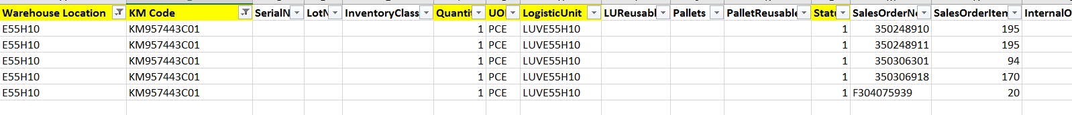

Now MES is showing there is no Sales Order number and all the 5 pieces are summarized. Correct would be to see 5 lines in the same location same LUV but the unique Sales Order number.

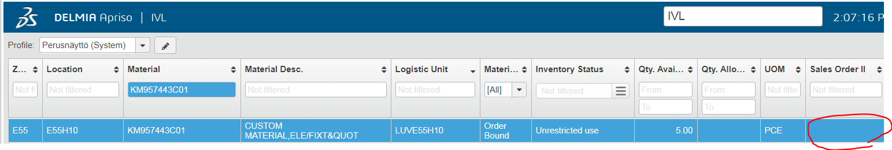

Case #2

Upload file has same material with 4 different LU’s in the same location but each LU with its unique Sales Order number.



MES is not showing the Sales Order number

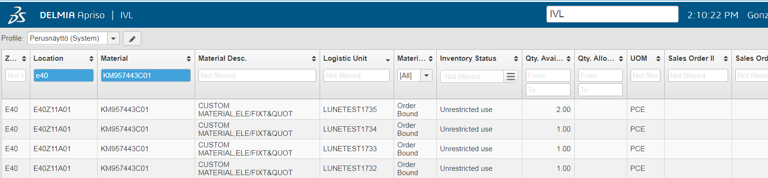

10.51.28.12